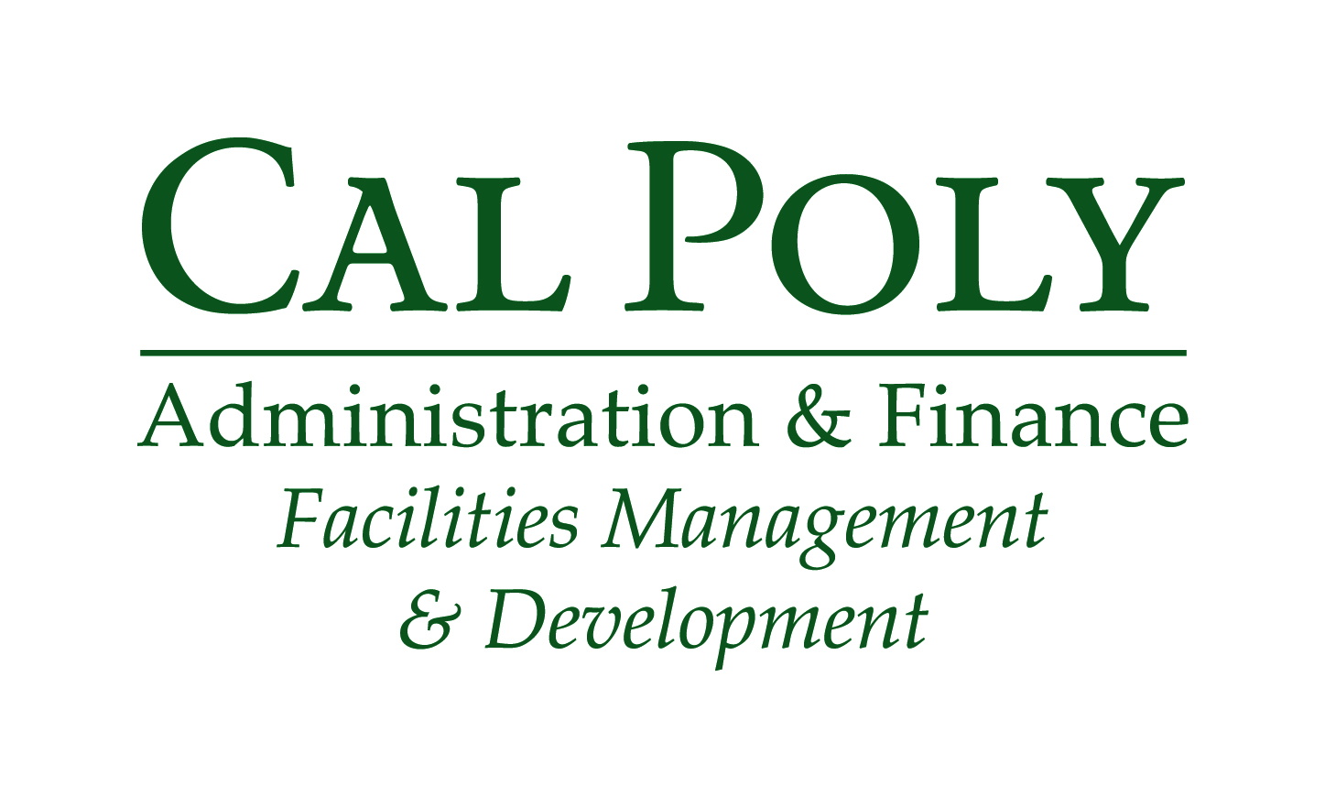
Facilities Operations Surplus Pickup Form
Please review the following information and complete this form so that we may better serve you.
- We cannot remove state property without a “Red Tag”. If the item has a silver “property of the state” sticker, you must first contact Property Accounting office at 6-2570 to have the item “Red-Tagged”.
- All file cabinets, desk drawers, bookcases, etc. MUST be emptied prior to pick-up.
- Boxes of discard items need to be stackable and packed to a manageable weight.
- All items must be CLEARLY marked for surplus.
- We will move the items checked below as soon as possible.

Red Tag Item (s): | YES: | No:

Contact: | Ext: | Fax: | Date:

Location of Items: | Building: | Room Number:

Please Provide Chartfield String: | Fund  (5 digits) | Dept ID  (6 digits) | Account  (6 digits) | Program  (5 digits) | Grant / Project  (6 digits) | Class  (5 digits)
 |  |  | 617001

Please fill out the checklist below as accurately as possible. Please indicate the quantity of each item in the space provided. Only the checked items that have been clearly marked will be picked up on the scheduled day.

Lateral File Cabinet: | Large Table: | Whiteboard:
Vertical File Cabinet: | Bookcase: | Boxes:
Modular Desk: | Credenza: | Shelves:
Standard Desk: | Chairs: | Pictures:
Small Table: | Bulletin Board: | Other:
Medium Table: | Chalkboard:
Disassemble desk or detach bookcase from wall: YES
Other Information:

Please email this form to:
facilities-cbs@calpoly.edu
Building 70 - Office: 805-756-5555

