CMS Business Process Guide
Multiple Jobs Summary

The Multiple Jobs Summary allows you to view a summary of all jobs and changes in job status for an individual employee. Multiple employment records will appear for employees that have more than one job. Job changes may be viewed by clicking on the arrows in the title bar.

You will have access to employees in the departments to which you have been granted access. In addition, you will have access to all jobs for those employees regardless of the departments to which they are assigned. You will not have access to employees if none of their jobs are in a department to which you have been assigned.

This guide explains the various fields or “data elements” of which a position record is comprised. Below are the position web pages/tabs and links on which a position record’s data elements reside:

- Employee
- Position Data
- Job Information

NAVIGATION: Main Menu > Workforce Administration > Job Information > Review Job Information > Multiple Jobs Summary
- Employee Tab
Back to top
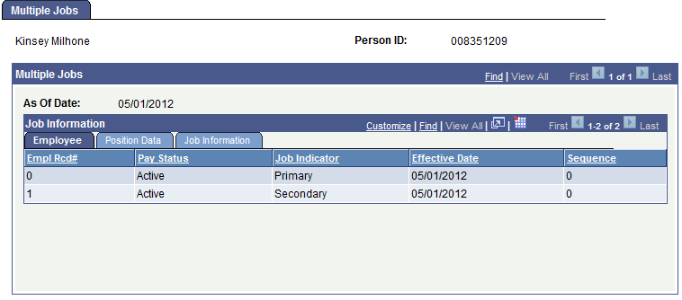

Multiple Jobs
As Of Date | Effective Date of the job data displayed
Job Information Section
Empl Rcd # | System-assigned number for this job or employee record
Pay Status | Active or inactive position status
Job Indicator | Reason for the position transaction
Effective Date | Date the position transaction was entered into PeopleSoft
Sequence | Sequence of job rows for job rows with the same effective dates

- Position Data Tab
Back to top

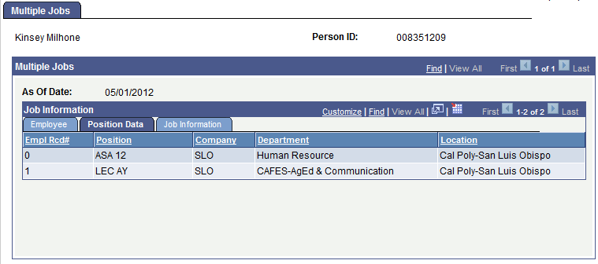

Empl Rcd # | System-assigned number for this job or employee record
Position | Brief job classification title
Company | Campus identifier
Department | Department name
Location | Campus identifier

- Job Information Tab
Back to top

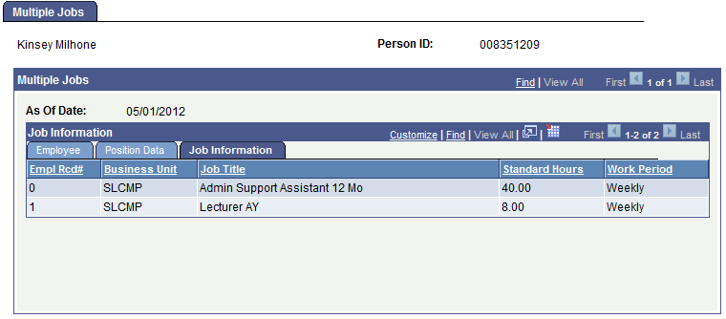

Empl Rcd# | System-assigned number for this job or employee record
Business Unit | An identification code that represents a high-level organization of business information
Job Title | Abbreviated job classification title; if MPP, abbreviated working title
Standard Hours | Derived from FTE and reflects the number of hours the incumbent is regularly scheduled to work (Due to system requirements hourly-intermittent positions will have 40 hours in this field)
Work Period | Time period in which incumbent must complete the standard hours

Back to top

