What is a wire transfer?
A wire transfer is a payment made to a foreign vendor by electronically transferring payment form CPSU’s bank account directly to the vendor’s bank account. Generally, wire transfers are accepted world-wide, though a wire transfer cannot be processed to a sanctioned country.

When is it appropriate to request a wire transfer?
Wire transfers are used to foreign vendors only. A wire transfer may be the best payment method when:
- The vendor will have difficulty cashing a check drawn on a U.S. bank account or issued in U.S. dollars
- The time to mail a check overseas, and the risk that the check may be lost in the mail, are not acceptable
Processing a wire transfer is manual and costly, so this payment method should be used only when it makes good business sense.

Before requesting a wire transfer:
- Make sure to have a department authorized vendor invoice.
- Check with Payment Services to see if the vendor is already setup in our PeopleSoft System. If not, we will need to get information from them, to have them set up as a vendor in our system before a wire payment can be issued.

Transfers can be created by…
- Bernadette Monterrosa
- Dave Marshall

Once entered, transfers can be approved by…
- Marc Benadiba
- David Valdez

Strategic Business Services has installed a 3-day business turnaround time to complete a wire payment. So, the wire should be setup to go out the third day after Payment Services provides the wire request. This gives Marc both the time to review and approve the Wire Payment.
If more than one bank on your paperwork, make sure to circle or clearly indicate which bank to use.
Make sure following information on the following page (Required Bank Information for a Wire Payment) is included and legible.

Required Bank Information for a Wire Payment

Payee (Beneficiary) Information
Vendor Name _____________________________________________
Street Address _____________________________________________
City and Country _____________________________________________

Bank Information
Bank name _____________________________________________
Bank Address _____________________________________________
Name on Account _____________________________________________
Payee Bank Account Number _____________________________________________
SWIFT code (8-11 digits alphanumeric) _____________________________________________
IBAN (Primarily Europe – length varies) _____________________________________________
CLABE (Mexico wires – 18 digits) _____________________________________________
IRC/Sort Code/Other Banking Codes, please specify: _________________________________________

Bank Code Definitions for Requesting Wires IBAN, SWIFT / BIC and CLABE

Required banking codes for wires in:
- Foreign currency the SWIFT / BIC is needed

If the Payee bank is part of the European Community (see below list), the IBAN and SWIFT / BIC are required.

What is the IBAN? (International Bank Account Number)
- The IBAN is a series of alphanumeric characters which uniquely identify an account held at a bank. It can be up to 34 characters long and contains a two-character country code, two check digits, and the basic bank account number. The basic bank account number identifies the bank as well as the account holder. In printed format, spaces are inserted for readability (i.e. DE16 5003 3300 0532 0130 00).

What is the BIC? (Bank Identifier Code)
- The BIC is an 8-character code also known as the SWIFT address and is uniquely assigned to banks. Branch codes can be added to the BIC to further designate which branch of a bank should receive the SWIFT message. When a branch code is added, the BIC has 11
characters (i.e. BARCGB22 or DEUTDE3B400).

What is CLABE? (Clave Bancaria Estandarizada)
- The CLABE is a banking standard for the numbering of bank accounts in Mexico. This standard is a requirement for the sending and receiving of international transfers since June 1, 2004. The CLABE account code has 18 digits.

IBAN and SWIFT / BIC are REQUIRED on invoices (European Community)
- The European Payments Council requires that all European banks provide their account holders with their IBAN and BIC. Additionally, the account holders are required to provide these two pieces of information on any documents used in cross-border invoicing.

Country | IBAN  Length | Country | IBAN  Length | Country | IBAN  Length
Andorra | 24 | Gibraltar | 23 | Norway | 15
Austria | 24 | Greece | 27 | Poland | 28
Belgium | 16 | Hungary | 28 | Portugal | 25
Czech Republic | 24 | Iceland | 26 | Slovenia | 19
Denmark | 18 | Ireland | 22 | Spain | 24
Finland | 18 | Italy | 27 | Sweden | 24
France | 27 | Luxembourg | 20 | Switzerland | 21
Germany | 22 | The Netherlands | 18 | United Kingdom | 22

Foreign Currency Conversion

When a vendor invoices in a foreign currency, the amount has to be converted into US Dollars using a Currency Converter: https://www.oanda.com click on Currency Converter. Example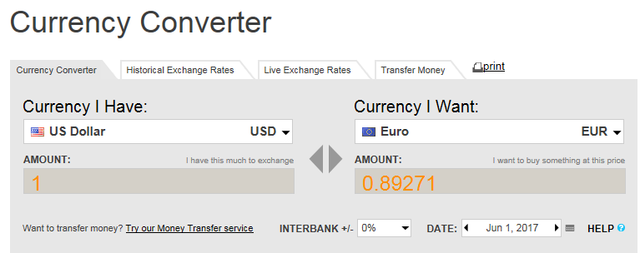
The invoice date is the date used to convert the currency from foreign currency to US dollar currency. Please attach the conversion sheet to the invoice when submitting it for payment processing.

