Procedure Guidelines and Business Process Guide
Department: Fiscal Services - Cashiering
Procedure Title: Payroll Distribution
Author(s): Kathryn Dunham, Brett Holman
Date: 9/27/12
ICSUAM Policy/ authoritative source(s): N/A
Revision History
Date | By | Action | Pages
9/27/12 | Kathryn Dunham | Creation | 5
12/21/12 | Kathryn Dunham | Revision – Added Distrib to 3rd Party | 5
10/7/13 | Kathryn Dunham | Revision – Contact name change | 5
12/10/13 | Kathryn Dunham | Revision – Distribution Authorization Requirements | 5

Background / Scope:
The University Cashiers Office is responsible for the distribution of Payroll checks (checks) and direct deposit advices (DD advices) (collectively aka “payroll” or “warrants”) for State Employees. Both types of warrants should be treated equally. The three paydays each month are as follows:
- Staff Hourly, Overtime & Shift Differential Payday ~15th
- Special Pay (i.e. SC101) and Late Staff Hourly Payday ~25th
- Faculty / Staff Payday ("Master Payroll") ~ last business day of the month
The Payroll Department creates the Payroll Calendar which identifies these dates for each month and can be found in the following location in the “Faculty and Staff Pay and Leave Forms” section:
http://www.afd.calpoly.edu/payroll/forms.asp?form=20

Master Payroll Distribution (end of the month)
- Generally, Master Payroll is distributed between 3:00 pm (no earlier) – 4:00 pm. There is one Cashier that is primarily responsible for distributing payroll. After the initial rush any Cashier can distribute warrants if the Cashier responsible for payroll is unavailable.
- Warrants may only to be distributed to those authorized personnel who are listed on the Pay Warrant and Direct Deposit Advice Distribution Authorization Form (Distribution Authorization Form) which is authorized & signed by the Dean/Department Head. Authorization to pick up Payroll may not be granted to anyone with authorization to hire &/or approve (not review) Payroll. On an exception-basis only, the person who authorizes the departmental Authorization Form can send an email to universitycashier@calpoly.edu authorizing someone other than those listed on the Form to pick up payroll.
- If any of the individuals that are authorized to pick up payroll warrants change, or need to be modified, the Pay Warrant and Direct Deposit Advice Distribution Authorization Form in its entirety will need to be resubmitted listing all of the currently authorized names with signatures.
- Photo identification is required for each person picking up warrants.
Distribution Authorization Form file location:
http://www.afd.calpoly.edu/fiscalservices/forms.asp
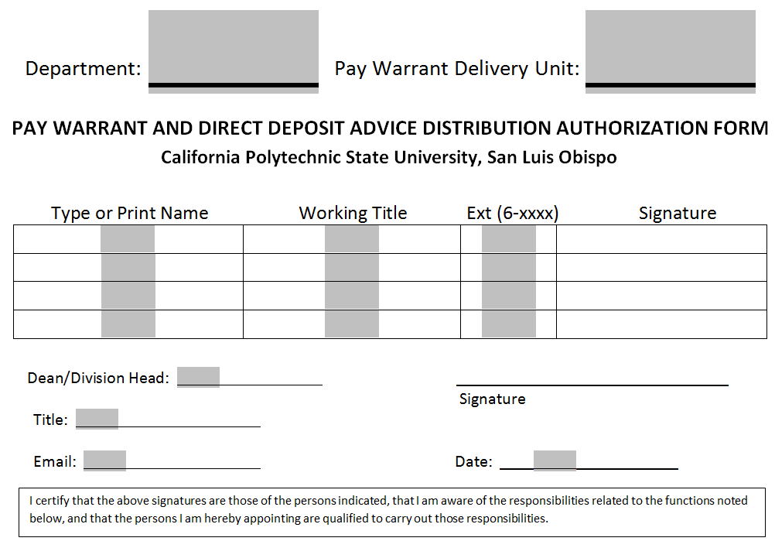
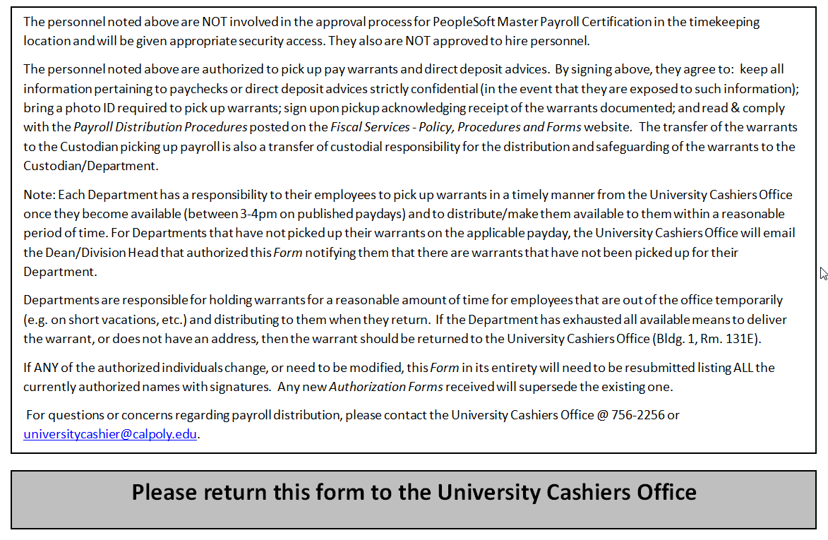
- The authorized person (Departmental Payroll Warrant Custodian (Custodian)) picking up payroll will receive a Unit Listing of Individual Warrants (Listing) comprised of a detailed list of the warrants that they are picking up. They must sign the Unit Payroll Distribution Signature Sheet attesting that they have received all warrants per the Listing.
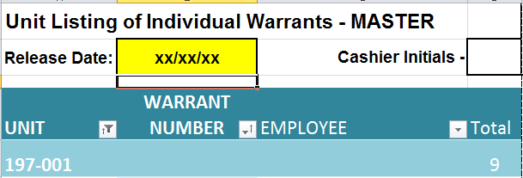
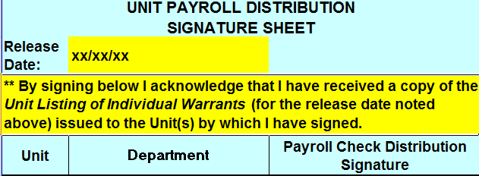
- An authorized person from each Department must pick up payroll warrants distributed for the Master payday for their entire department. Master payroll warrants will not be distributed from the University Cashiers Office to individuals. Individuals are allowed to pick up all other types of warrants throughout the month from the University Cashiers Office.

Post Distribution
- The transfer of the warrants to the Custodian picking up payroll is also a transfer of custodial responsibility for the distribution and safeguarding of the warrants to the Custodian/Department.
- The Custodian must have the ability to store the warrants in a locked drawer or cabinet if they are not able to distribute the warrants immediately.
- Custodians may require verification of warrant transfer to the employee in the form of initials on the Unit Listing of Individual Warrants if the Custodian so chooses. The Listing of warrants provided to the Custodian includes a checkbox that the Department can use to require employees to initial when they pick up their individual warrant from the Department.
- Departments are responsible for holding warrants for a reasonable amount of time for employees that are out of the office temporarily (e.g. on short vacations, etc.) and distributing to them when they return. If the employee is away from Cal Poly for a longer period of time (e.g. an extended vacation, medical leave, etc.) then the Department must make a reasonable effort to send the warrant to the employee if they have the employee’s address or arrange for them to pick up the warrant directly from the Department. If the Department has exhausted all available means to deliver the warrant, or does not have an address, then the warrant should be returned to the University Cashiers Office.

Distribution to a Third Party
- Employees are required to pick up their paycheck in person from their department; however, in exceptional circumstances it may be necessary for the employee to allow a third party to collect their paycheck on their behalf. Should that become necessary, the employee must make the following advance arrangements with the University Cashiers Office:

- The employee will provide a request to the University Cashiers Office naming the third party who is approved to pick up their check. The request can be either:

    - A written request, signed by the employee, and delivered in person by the employee to the Cashiers Office (a photo ID will be required)

    - Or, an email request that is sent directly from the employee’s Cal Poly email address to the University Cashiers’ email address: universitycashier@calpoly.edu

- Alternate arrangements from those listed above may be accommodated, subject to pre-approval by the Lead Cashier

Note: The third party will be required to show their photo ID at the time of pickup.

Undistributed Warrants
- Each Department has a responsibility to their employees to pick up warrants in a timely manner from the University Cashiers Office once they become available and to distribute/make them available to them within a reasonable period of time. For Departments that have not picked up their warrants on the applicable payday, the University Cashiers Office will email the Dean/Division Head that authorized the Pay Warrant and Direct Deposit Advice Distribution Authorization Form notifying them that there are warrants that have not been picked up for their Department.

Non-Master Paydays
There are two paydays during each month in addition to Master Payday:
- Staff Hourly, Overtime & Shift Differential Payday ~15th
- Special Pay (i.e. SC101) and Late Staff Hourly Payday ~25th
The same process is followed for these paydays as Master with the exception of the following:
- Individuals are allowed to pick up individual warrants for these paydays from the University Cashiers Office.
- Warrants for the Facilities Units are not segregated out since payroll for all Departments is distributed at 3:00 pm each payday)

CONTACT(S):
Office and contact name: Phone Ext: Email:
Michelle Molnar 6-6089 mrmolnar@calpoly.edu
(University Cashiers Office ~ Cashier)
Kathryn Dunham 6-2310 kdunham@calpoly.edu
(University Cashiers Office ~ Lead)

