CMS Business Process Guide
Job Data
The Job Data module stores employees’ employment histories or “job records.” A job record consists of effective-dated “rows” of personnel transactions starting with the employee’s hire. An employee may hold multiple jobs/job records, which are identified by the “Employee Record #”, or “Empl Rcd #” for short, and is displayed at the top of each page of Job Data.
This guide explains the various fields or “data elements” of which a job record is comprised. Below are the Job Data web pages:
Work Location
Job Information
Job Labor
Payroll
Salary Plan
CSU Job
Compensation
CSU Faculty Job
Employment Data
NAVIGATION: Workforce Administration > Job Information > Job Data

Work Location
Back to top
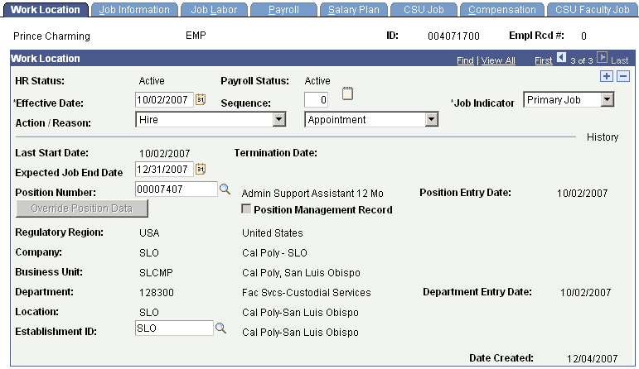

Work Location
ID | System-assigned Employee ID for this employee
Empl Rcd # | System-assigned number for this job or employee record
HR Status | System-assigned employee status for the HR module based on the job action
Payroll Status | System-assigned employee status for the Payroll module based on the job action
Effective Date | Effective date of the personnel transaction or job row
Sequence | Sequence of job rows for job rows with the same effective dates
Job Indicator | Identifies whether this job is Primary or Secondary
Action | The category of personnel transaction being processed for an employee
Reason | Further defines the Action category
Last Start Date | Latest date this employee was hired or rehired into this Employee Record
Termination Date | Date that this employee was terminated from this Employee Record
Expected Job End Date | Date this appointment is expected to end
Position Number | Identifies the position the employee occupies
Position Entry Date | Date on which the employee last entered the Position
Position Management Record | Not used at Cal Poly
Regulatory Region | Determines how the system processes data for this job
Company | Campus identifier
Business Unit | An identification code that represents a high-level organization of business information
Department | The code of the department to which an employee has been assigned
Department Entry Date | Date on which the employee was last assigned to the department
Location | Campus identifier
Establishment ID | Campus identifier
Date Created | Date the Job row was first entered into PeopleSoft

Job Information
Back to top
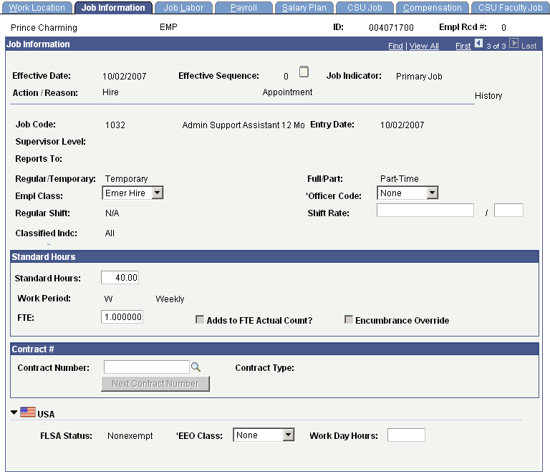

Job Information
Job Code | Identifies the job classification of the employee
Entry Date | Date on which the employee was last assigned to the job code displayed
Supervisor Level | Not Used at Cal Poly
Reports To | Not Used at Cal Poly
Regular/Temporary | Indicates if employee is regular or temporary employee
Full/Part | Indicates whether an employee is a full or part-time employee
Empl Class | Defines the type of appointment for this job row
Officer Code | Not Used at Cal Poly
Regular Shift | Not Used at Cal Poly
Classified Indc | Not Used at Cal Poly
Standard Hours | Derived from FTE and reflects the number of hours the employee is regularly scheduled to work (Due to system requirements hourly-intermittent employees will have 40 hours in this field)
Work Period | Time period in which employees must complete the standard hours
FTE | Percentage of full time the employee should normally work in this job (Due to system requirements hourly-intermittent employees will have 1.0 fte in this field)
Adds to FTE Actual Count | When checked, will add fte amounts from other jobs
Encumbrance Override | Not Used at Cal Poly
Contract Number | Not Used at Cal Poly
Contract Type | Not Used at Cal Poly
FLSA Status | Indicates whether a Job Code/Salary Grade is subject to overtime pay (exempt/nonexempt) based on the Fair Labor Standards Act
EEO Class | This field is used to include or exclude an employee from EEO / IPEDS reporting, based upon the value selected
Work Day Hours | Not Used at Cal Poly

Job Labor
Back to top
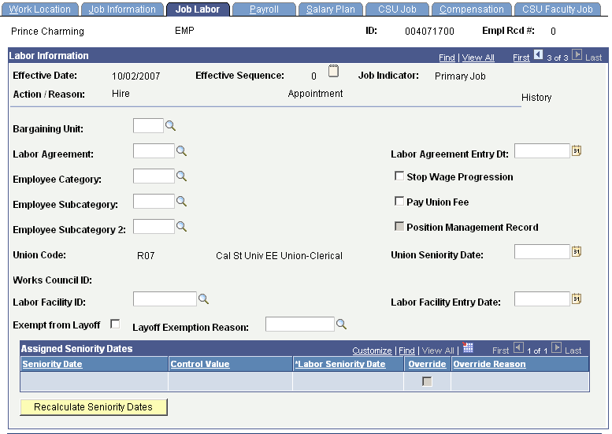

Job Labor
Union Code | Bargaining Unit identifier associated with job code of position
All other fields | Not used at Cal Poly

Payroll
Back to top
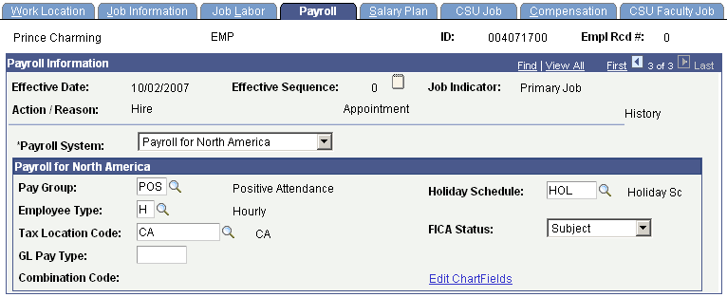

Payroll
Payroll System | Payroll System used to link Payroll-related modules
Pay Group | Identifies the type of employment for attendance purposes
Holiday Schedule | Holiday Schedule, required set-up but not used at Cal Poly
Employee Type | Hourly or Salaried, based on Pay Group
Tax Location Code | Identifies State where payroll is processed
FICA Status | Not Used at Cal Poly; FICA Status is incorporated with Retirement Code in the CSU
GL Pay Type | Not Used at Cal Poly
Combination Code | Not Used at Cal Poly
Edit Chartfields | Not Used at Cal Poly

Salary Plan
Back to top
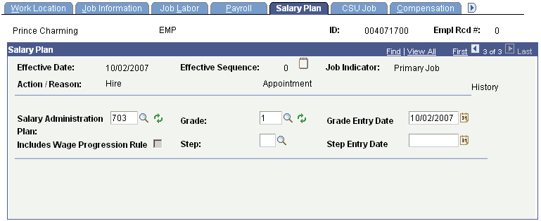

Salary Plan
Salary Administration Plan | Identifies those Job Codes that share the same Salary Grade information
Grade | Identifies the range or level in the salary schedule associated with the job code for the position
Grade Entry Date | Date the employee last entered this grade
Includes Wage Progression Rule | Not Used at Cal Poly
Step | If the Job Code has a step structure, the Salary Step indicates the step number within a given Salary Grade
Step Entry Date | Date the employee last entered the Step

CSU Job
Back to top
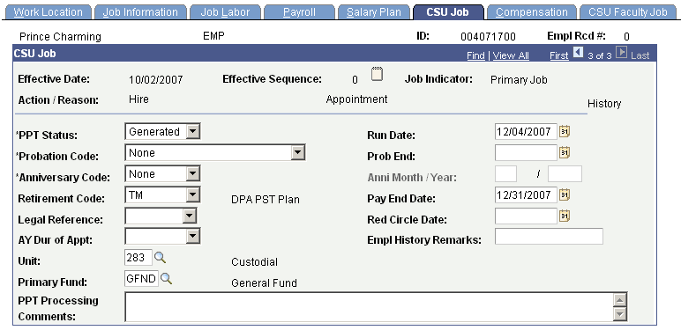

CSU Job
PPT Status | Status of Personnel Payroll Transaction (PPT) form – for some job actions a PPT is generated for the Payroll Office for input into the State Controller’s Office (SCO) payroll system
Run Date | Date PPT was generated
Probation Code | Probation or Tenure status
Prob End | End date of Probationary period
Anniversary Code | Indicates eligibility to receive a Service-Based Salary Increase (SSI)
Anni Month/Year | Pay month and year in which eligible to receive an SSI
Retirement Code | Indicates employee’s retirement system (code incorporates FICA status in the CSU)
Pay End Date | Indicates the expected last pay date for the employee
Legal Reference | Cites a specific reference in the law under which a retired CalPERS annuitant may be employed by CSU without reinstatement from retirement status or loss of retirement benefits
Red Circle Date | This reflects the Red Circled salary expiration date for an employee who has been formally assigned a salary rate over the maximum of the salary range, per the appropriate MOU
AY Dur of Appt | Track duration of temporary, academic year appointments
Empl History Remarks | Comments for the SCO Payroll System
Unit | Paycheck delivery identifier
Primary Fund | Indicates the primary funding source that will pay for ongoing or one time costs of performance or merit comp increases
PPT Processing Comments | Comments that will print on PPT used for communication to Payroll regarding processing

Compensation
Back to top
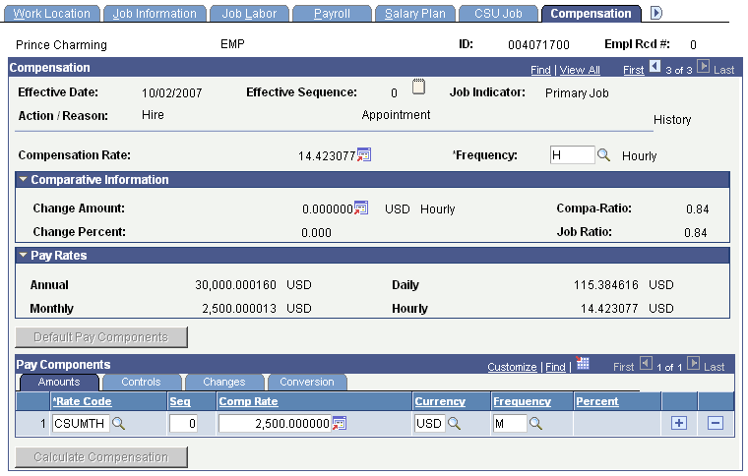

Compensation
Compensation Rate | Actual salary rate based on employee’s actual FTE; expressed as an hourly rate for hourly employees
Frequency | Identifies the basis for computing an employee's Compensation Rate
Change Amount | Compensation difference from the previous job row
Compa-Ratio | Displays the percent-through-range calculation, based on the salary plan and grade
Change Percent | Percent change in compensation from the previous job row
Job Ratio | Displays the percent-through-range calculation, based on the midpoint salary of the person’s job code
Annual | Compensation Rate displayed at an annual rate
Daily | Compensation Rate displayed at an daily rate
Monthly | Compensation Rate displayed at an monthly rate
Hourly | Compensation Rate displayed at an hourly rate
Rate Code | Identifier for pay components. Defines rates of pay
Seq | Effective sequence of compensation rows
Comp Rate | Represents the full-time equivalent salary amount for the position. The salary reflected is expressed in a monthly or hourly rate based on the CSU salary schedule.
Currency | Currency code upon which the compensation rate will be based
Frequency | Identifies the basis for computing an employee's Compensation Rate

CSU Faculty Job
Back to top
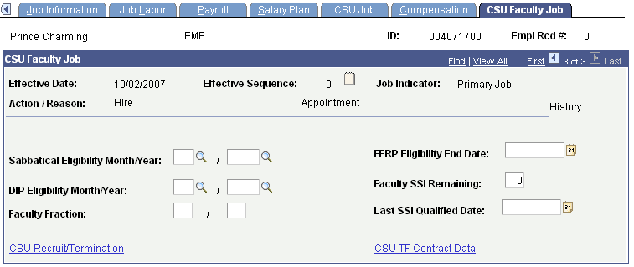

CSU Faculty Job
Sabbatical Eligibility Month/Year | Month in which a faculty member has or will attain eligibility for a Sabbatical Leave per the MOU
FERP Eligibility End Date | Participation end date in Faculty Early Retirement Program per MOU
DIP Eligibility Month/Year | Year in which a faculty member has or will attain eligibility for a Difference in Pay Leave per the MOU
Faculty SSI Remaining | Number of Salary Service Increases a faculty member has remaining based on the MOU
Faculty Fraction | Faculty member timebase expressed as a fraction
Last SSI Qualified Date | Last date faculty member received an SSI
CSU Recruit/Termination | Link to CSU Recruit module
CSU TF Contract Data | Link to Temporary Faculty Contract Data module
- Back to top

Employment Information
Back to top
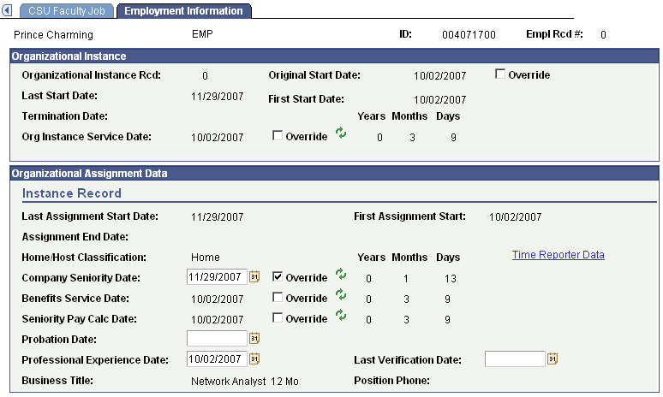

Employment Information
Organizational Instance Rcd | Represents a particular job associated with the Empl ID
Original Start Date | Date of employee’s first assignment at Cal Poly
Last Start Date | Latest date this employee was Hired or Rehired into this position
First Start Date | First date this employee was Hired or Rehired into this position
Termination Date | Date employee was Terminated from this position
Org Instance Service Date | Date employee was first appointed to this Organizational Instance
Last Assignment Start Date | Not used at Cal Poly
First Assignment Start | Not Used at Cal Poly
Assignment End Date | Not Used at Cal Poly
Home/Host Classification | Not Used at Cal Poly
Company Seniority Date | Start date used for service awards creditable service, adjusted for certain leaves and breaks in service
Benefits Service Date | Not Used at Cal Poly
Seniority Pay Calc Date | Not Used at Cal Poly
Probation Date | Not Used at Cal Poly
Professional Experience Date | Employee’s earliest Hire date; reset to Rehire date if there was a break in service
Business Title | Position Title from the Position Mgmt module
Last Verification Date | Not Used at Cal Poly
Position Phone | Not Used at Cal Poly
Back to top

