CMS Business Process Guide
Position Management
The Position Management module stores effective-dated histories of all positions (position records) regardless of whether they are filled. A position may be filled by more than one incumbent. Position records consist of rows of position transactions starting with the creation of the position.
This guide explains the various fields or “data elements” of which a position record is comprised. Below are the position web pages/tabs and links on which a position record’s data elements reside:
Description
Specific Information
Budget and Incumbents
CSU Position Data
NAVIGATION: Organizational Development > Position Management >
Maintain Positions/Budgets > Add/Update Position Info

Description
Back to top
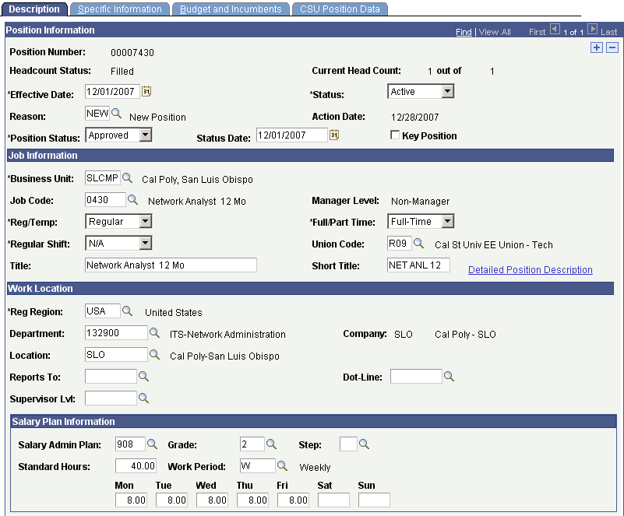

Position Information
Position Number | The unique number assigned to the position
Headcount Status | Indicates filled or unfilled status
Current Head Count | Actual number of incumbents vs. total number allowed
Effective Date | Effective date of the position transaction
Status | Active or inactive position status
Reason | Reason for the position transaction
Action Date | Date the position transaction was entered into PeopleSoft
Position Status | Indicates when the position is Approved, Frozen, or Proposed.
Status Date | Indicates the date for the position status
Key Position | Identifies positions for which the incumbent is subject to Conflict of Interest filing requirements

Job Information
Business Unit | An identification code that represents a high-level organization of business information
Job Code | Identifies the job classification of the position
Manager Level | Not used at Cal Poly
Reg/Temp | Indicates whether the position is regular or temporary
Full/Part Time | Indicates whether the position is full or part-time
Regular Shift | Not used at Cal Poly
Union Code | Bargaining Unit identifier associated with the job code of the position
Title | Abbreviated job classification title; if MPP, abbreviated working title
Short Title | Brief job classification title
Detailed Position Description | Full job classification title; if MPP, full working title

Work Location
Reg Region | Determines how the system processes data for this position
Department | The code and name of the department to which an employee has been assigned
Company | Campus identifier
Location | Campus identifier
Reports To | Not used at Cal Poly
Dot-Line | Not used at Cal Poly
Supervisor Lvl | Not used at Cal Poly

Salary Plan Information
Salary Admin Plan | Identifies those Job Codes that share the same Salary Grade information
Grade | Identifies the range or level in the salary schedule associated with the job code for the position
Step | If the Job Code has a step structure, indicates the lowest step number within a given Salary Grade
Standard Hours | Derived from FTE and reflects the number of hours the incumbent is regularly scheduled to work (Due to system requirements hourly-intermittent positions will have 40 hours in this field)
Work Period | Time period in which incumbents must complete the standard hours
FLSA Status | Indicates whether a Job Code/Salary Grade is subject to overtime pay (exempt/nonexempt) based on the Fair Labor Standards Act
Bargaining Unit | Not used at Cal Poly

Specific Information
Back to top
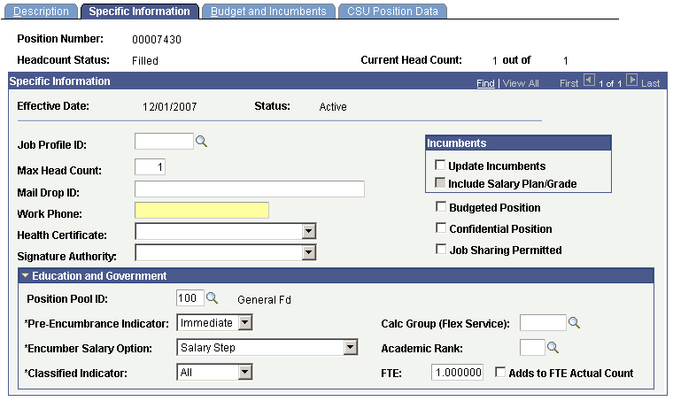

Specific Information
Job Profile ID | Identifies the job classification of the employee
Max Headcount | Maximum number of incumbents allowed
Mail Drop ID | Not used at Cal Poly
Update Incumbents | Not used at Cal Poly
Include Salary Plan/Grade | Not used at Cal Poly
Work Phone | Not used at Cal Poly
Budgeted Position | Not used at Cal Poly
Health Certificate | Not used at Cal Poly
Confidential Position | Not used at Cal Poly
Signature Authority | Not used at Cal Poly
Job Sharing Permitted | Not used at Cal Poly
Position Pool ID | Funding pool for the position
Pre-Encumbrance Indicator | Not used at Cal Poly
Calc Group | Not used at Cal Poly
Encumber Salary Option | Not used at Cal Poly
Academic Rank | Not used at Cal Poly
Classified Indicator | Not used at Cal Poly
FTE | Percentage of full time the employee should normally work in this job (Due to system requirements hourly-intermittent employees will have 1.0 fte in this field)
Adds to FTE Actual Count | Not used at Cal Poly

Budget and Incumbents
Back to top
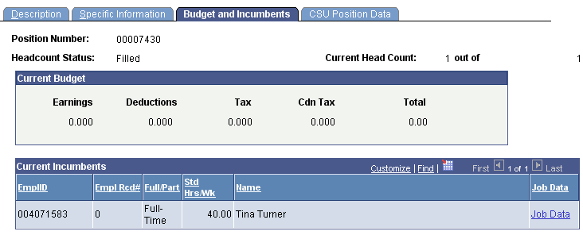

Current Incumbents
EmplID | Employee ID of the current incumbent
Empl Rcd# | Job or Employee Record in which the incumbent is assigned to this position
Full/Part | Indicates whether the incumbent is a full or part-time employee
Std Hrs/Wk | Derived from FTE and reflects the number of hours the incumbent is regularly scheduled to work (Due to system requirements hourly-intermittent employees will have 40 hours in this field)
Name | Incumbent’s name
All other fields on page | Not used at Cal Poly

CSU Position Data
Back to top
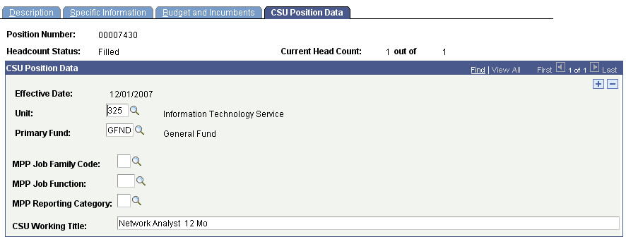

CSU Position Data
Unit | Paycheck delivery identifier
Primary Fund | Indicates the primary funding source that will pay for ongoing or one time costs of performance or merit comp increases
MPP Job Family Code | Family of job functions that share similarities in the nature of work  MPP Codes are used for the MPP Job Reporting System to meet federal and state reporting requirements and CSU reporting needs
MPP Job Function | Work activities commonly associated with a particular occupational group or discipline.
MPP Reporting Category | Used to assign the appropriate Affirmative Action Code
CSU Working Title | Abbreviated job classification title

